SOFTWARE DESIGN DOCUMENT
for
APPOINTMENT MANAGEMENT SYSTEM

Prepared by
Mustafa BALABAN
Kamil DURU
Husniddin RAMAZANOV
Onur BİLGİN

TABLE OF CONTENTS
1 Introduction 3
1.1 Purpose of the system 3
1.2 Design goals 3
1.3 Definitions, acronyms, and abbreviations 3
1.4 References 3
1.5 Overview 3
2 Current software architecture 3
3 Proposed software architecture 3
3.1 Overview 3
3.2 Subsystem decomposition 3
3.3 Hardware/software mapping 3
3.4 Persistent data management 4
3.5 Access control and security 4
3.6 Global software control 4
3.7 Boundary conditions 4
4 Subsystem services 4
5 Glossary of Terms 4
6 Traceability 4

Introduction

This Software Design Document (SDD) describes the architectural design and detailed structure of the Appointment Management System (AMS) developed for small service sector businesses. The document provides an overview of the system’s purpose, design goals, key terminology, and references to related documents. It serves as a technical blueprint that guides developers, testers, and stakeholders throughout the implementation, validation, and maintenance phases of the system.

The SDD translates the functional and non-functional requirements defined in the Requirements Analysis document into a concrete software architecture. It identifies the major system components, their responsibilities, interactions, and the constraints that influence design decisions. This document is intended to ensure traceability between requirements and design while promoting consistency, scalability, and maintainability.

Purpose of the system

The purpose of the Appointment Management System is to provide a centralized, reliable, and efficient platform for managing appointments, resources, services, and clients in small service-oriented businesses such as salons, clinics, spas, and repair shops. The system aims to replace manual or insufficient scheduling methods with an automated solution that minimizes booking conflicts, optimizes resource utilization, and improves customer experience.

AMS enables business owners and staff to manage personnel schedules, equipment availability, and service offerings, while allowing clients to book appointments through web and mobile interfaces. By ensuring real-time synchronization and enforcing scheduling constraints, the system supports accurate planning and operational efficiency.

Design goals

The primary design goals of the Appointment Management System are as follows:

Modularity and Maintainability: Design the system using well-defined, loosely coupled components to simplify maintenance and future enhancements.

Scalability: Support growth in the number of users, appointments, and resources without significant architectural changes.

Reliability and Consistency: Prevent overbooking and scheduling conflicts through strict data integrity rules and real-time synchronization.

Usability: Provide intuitive and user-friendly interfaces for both business staff and clients, minimizing training requirements.

Platform Accessibility: Ensure availability through both web and mobile applications.

Security: Protect sensitive client and business data using authentication, authorization, and secure communication mechanisms.

Extensibility: Allow integration with third-party services such as notification systems and external APIs.

Definitions, acronyms, and abbreviations

AMS: Appointment Management System

CRUD: Create, Read, Update, Delete

UI: User Interface

API: Application Programming Interface

JWT: JSON Web Token

REST: Representational State Transfer

Resource: Human personnel or equipment required to deliver a service

Client: End user who books services through the system

References

Software Requirements Specification (SRS) for Appointment Management System

IEEE 1016™ – IEEE Standard for Information Technology—Systems Design—Software Design Descriptions

Existing scheduling and booking systems used in small service sector businesses

Documentation of selected technologies (e.g., database systems, frameworks, notification services)

Overview

The remainder of this document details the architectural and detailed design of the Appointment Management System. Subsequent sections describe the overall system architecture, component-level design, data models, database schema, interaction flows, and design constraints. Together, these sections provide a comprehensive view of how the system is structured and how it fulfills the specified requirements.

Current software architecture

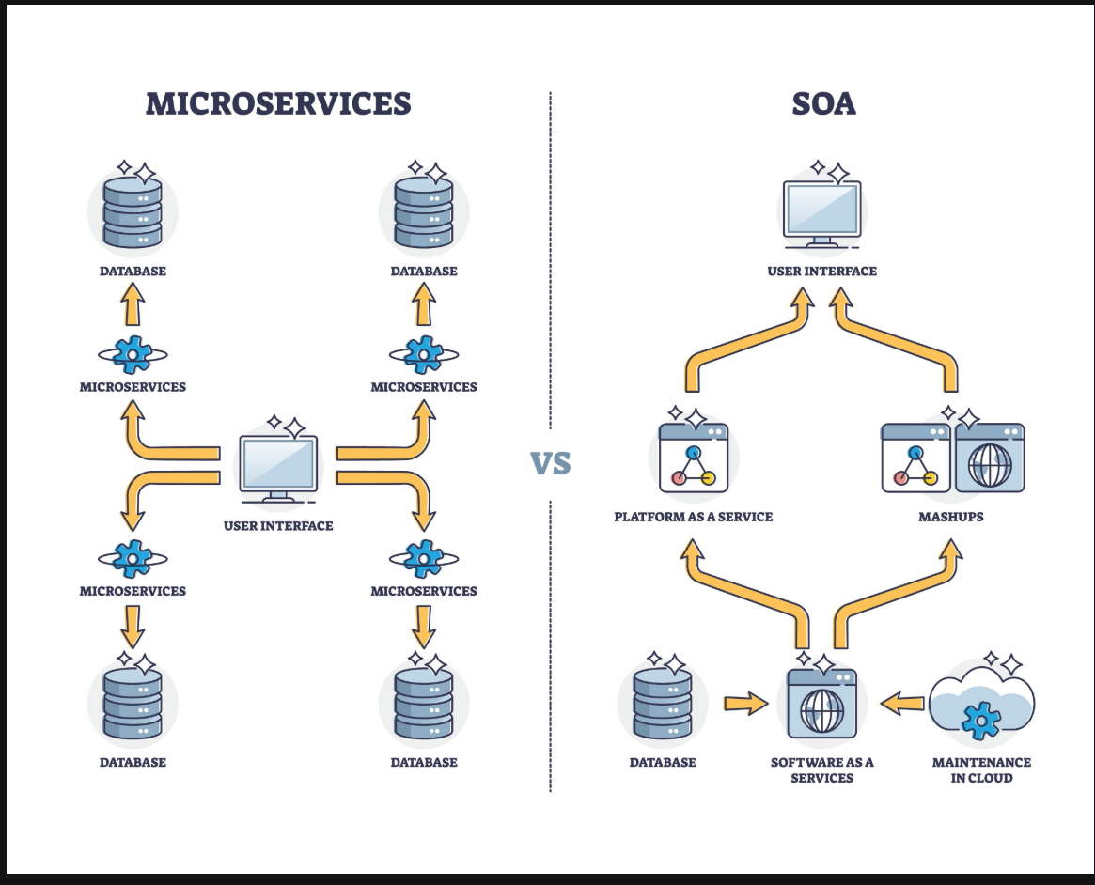

The current Appointment Management System is built upon a modern Distributed Microservices Architecture rather than a monolithic structure. This strategic decision was made to ensure high scalability, independence of deployment, and technological agility (Polyglot persistence). The system is fundamentally divided into three core layers: the Presentation Layer, the Application Layer, and the Data Layer. The Presentation Layer is served by a robust technology stack featuring Angular (TypeScript) for the web-based client portal and Flutter (Dart) for the cross-platform mobile application, ensuring a native-like user experience. The Application Layer, responsible for core business logic and service orchestration, is powered by Node.js. This choice was based on Node.js's asynchronous, non-blocking nature, which is ideal for handling the high volume of concurrent I/O operations typical of a scheduling and management system. Finally, the Data Layer relies on MongoDB, a NoSQL document database. The decision to use MongoDB was driven by the need for a flexible schema to accommodate dynamic data structures (like appointments and user profiles) and to support the horizontal scaling demands inherent in a microservices environment. The new system's development will specifically leverage the existing modularity but will focus on clearly defining microservice boundaries and reinforcing cross-service data integrity controls within this Node.js and MongoDB ecosystem.

Proposed software architecture

The proposed system will use a modern, layered architecture. It will include web and mobile interfaces, a backend API, and a NoSQL database (MongoDB). The goal is to allow real-time synchronization, secure data handling, and smooth appointment booking.

Overview

The system is divided into several major parts:

Frontend (Web and Mobile Apps)

The web app will be built with React.

The mobile app will be built with Flutter.
Both interfaces will be used by clients, staff, and admins to interact with the system.

Backend API

Built using Node.js (with Express or NestJS).
It contains all the business logic such as scheduling, appointment validation, resource management, and communication with the database.

Database Layer

The system uses MongoDB, a NoSQL database, to store persistent data such as clients, appointments, services, staff schedules, and equipment details.

Real-time Update System

Real-time updates will be handled using:

WebSockets (Socket.io)

This ensures updates (like new bookings or cancellations) appear instantly on all devices.

Notification Services

Handles email, SMS, and push notifications to customers and staff:

Could use services like Twilio, Firebase Cloud Messaging, or SendGrid.

This architecture helps keep the system organized, easy to maintain, and scalable for future improvements.

Subsystem decomposition

1. User Interface Subsystem

Handles all screens and user interactions in React (web) and Flutter (mobile).

Includes admin dashboards, staff calendars, and client booking interface.

2. Authentication and Authorization Subsystem

Manages login and user roles (admin, staff, client).

Uses token-based authentication (JWT).

Ensures only authorized users access certain features.

3. Scheduling and Appointment Subsystem

Responsible for checking staff and equipment availability.

Prevents double booking.

Supports rescheduling, cancellations, and waitlists.

4. Resource Management Subsystem

Manages staff and equipment information.

Handles working hours, breaks, qualifications, and maintenance periods.

5. Service Catalog Subsystem

Stores information about services: duration, price, required resources.

6. Client Management Subsystem

Manages client profiles, contact info, booking history, preferences.

7. Notification Subsystem

Sends reminders, confirmations, and cancellation alerts.

Integrates with email/SMS APIs.

8. Reporting Subsystem

Generates reports about bookings, staff workload, and cancellation patterns.

9. Database Access Subsystem

Connects the backend logic to MongoDB.

Uses Mongoose or another ODM to perform database operations.

Hardware/software mapping

The system will be deployed mostly on cloud infrastructure such as:

AWS

Google Cloud

Azure

Users will access the system through:

Web browsers (React app)

Mobile phones (Flutter app)

Software

Backend: Node.js

Database: MongoDB

Web Frontend: React

Mobile App: Flutter

Real-Time Communication: WebSockets (Socket.io)

Multi-node Issues (if system runs on multiple servers)

Keeping cached data consistent across servers

Handling simultaneous booking requests

Managing session tokens correctly

Synchronizing real-time updates across all nodes

Persistent data management

The system will store:

Users and roles

Staff data and working hours

Equipment data and maintenance periods

Service information

Client profiles and booking history

Appointments

Notifications

Logs (audit trails)

Database Choice: MongoDB

MongoDB is chosen because:

It stores flexible and dynamic schemas, which is useful for evolving features.

It handles large amounts of data efficiently.

It scales easily for cloud environments.

It works well with Node.js using Mongoose (ODM).

Data Access

The system will use Mongoose for managing MongoDB collections.

This simplifies queries and reduces the chance of inconsistent data.

Access control and security

Access Model
Role Permissions
Admin Full access
Staff Manage appointments, view schedule
Client Book and view their own appointments
Security Features

Global software control

User performs an action on React/Flutter app.

The frontend sends the request to the Node.js backend API.

Backend checks availability and business rules.

If valid, the appointment is stored in MongoDB.

Confirmation is sent back to the user.

WebSockets push real-time updates to connected clients.

Concurrency Handling

Since multiple users may book the same time slot:

MongoDB transactions or atomic operations will be used.

Backend logic will lock or block overlapping requests.

Real-time updates prevent users from seeing outdated information.

Caching (Redis optional) speeds up frequent availability queries.

Boundary conditions

System Start-up

On startup:

Node.js connects to MongoDB.

WebSocket server (Socket.io) starts.

Cache (if used) may warm up.

Notification services initialize.

System Shutdown

During shutdown:

API stops taking new requests.

Ongoing database operations finish.

Socket connections close cleanly.

Background jobs (notifications) stop safely.

Error Handling

The system will:

Reject invalid or conflicting bookings.

Retry failed notifications later.

Log errors for debugging.

Roll back partial writes to MongoDB.

Examples of Exceptions

Staff suddenly becomes unavailable

Equipment goes into maintenance

Client cancels just before the appointment

The system will automatically update schedules and notify affected users.

Subsystem services

This section lists the main operations provided by each subsystem.
4.1 User Interface Subsystem Services

Display dashboards for admins and staff

Show calendars, schedules, and appointment lists

Provide forms to book, edit, or cancel appointments

Provide interfaces to manage services, resources, and clients

Support login and registration

Display error messages, confirmations, and notifications

Guide clients through service selection and booking workflow

4.2 Authentication and Authorization Subsystem Services

Validate login credentials

Issue JWT tokens

Check user role and permissions

Verify token validity for each request

Handle logout and token expiry

4.3 Scheduling and Appointment Subsystem Services

Check availability of staff and equipment

Validate new appointments

Create appointments

Reschedule or modify appointments

Cancel appointments

Manage recurring appointments

Handle waitlists

Return appointment data (calendar/list format)

Notify other subsystems of changes

4.4 Resource Management Subsystem Services

Create, view, update, delete staff

Create, view, update, delete equipment

Set working hours and leave blocks

Set equipment maintenance periods

Check resource availability

Activate/deactivate resources

4.5 Service Catalog Subsystem Services

Add new services

Edit service details

Delete unused services

Retrieve service list

Retrieve required resources for each service

Retrieve pricing and duration

4.6 Client Management Subsystem Services

Create client profiles

Update client information

Retrieve client history

Store notes or preferences

View client appointment history

4.7 Notification Subsystem Services

Send booking confirmations

Send reminders

Send cancellation/reschedule alerts

Send staff shift notifications

Log notification results

Retry failed notifications

4.8 Reporting and Analytics Subsystem Services

Generate booking reports

Generate resource utilization reports

Summaries of cancellations and no-shows

4.9 Database Access Subsystem Services

Execute MongoDB queries

CRUD operations for all entities

Maintain data integrity

Run transactions or atomic operations

Optimize queries with indexes

Return structured data objects

4.10 Real-Time Synchronization Subsystem Services

Broadcast updates for new/rescheduled/canceled appointments

Update resource availability in real time

Sync admin and staff calendar views

Notify UI of immediate state changes via WebSockets

Glossary of Terms

The document incorporates a dedicated Glossary of Terms to standardize terminology and ensure absolute consistency throughout the specification, prioritizing the client’s preferred language and definitions. This section clarifies crucial abbreviations and concepts, such as AMS (Appointment Management System), API (Application Programming Interface), and JWT (JSON Web Token). Furthermore, it formally defines key domain-specific entities like the Client (the end-user booking services) and Resource (the human or equipment required to deliver the service), establishing a shared vocabulary for all stakeholders and preventing ambiguities related to the specific technologies used (Flutter, Node.js, MongoDB).

Traceability

The Traceability section is critical for maintaining alignment between the design blueprint and the original requirements outlined in the Requirements Analysis Document (SRS). It explicitly links fundamental design decisions—such as utilizing Flutter for the mobile app and Angular for the web client to meet the Platform Accessibility requirement—to their corresponding SRS items. For instance, the choice of a Microservices Architecture and horizontally scalable MongoDB directly traces back to the non-functional requirement for Scalability, which is essential for a high-volume application. Additionally, the implementation of JWT token-based authentication is traceable to the core Security requirements, proving that every major architectural component serves a verified business or technical need.

